CSA1411-COMPILER DESIGN

LAB EXPERIMENTS

NAME:- R KALAI AMUDHAN

REG NO:- 192511292

EXPERIMENT – 9:
AIM:-
- Implement a C program to eliminate left recursion from a given CFG.
S → (L) / a
L → L , S / S

CODE:-
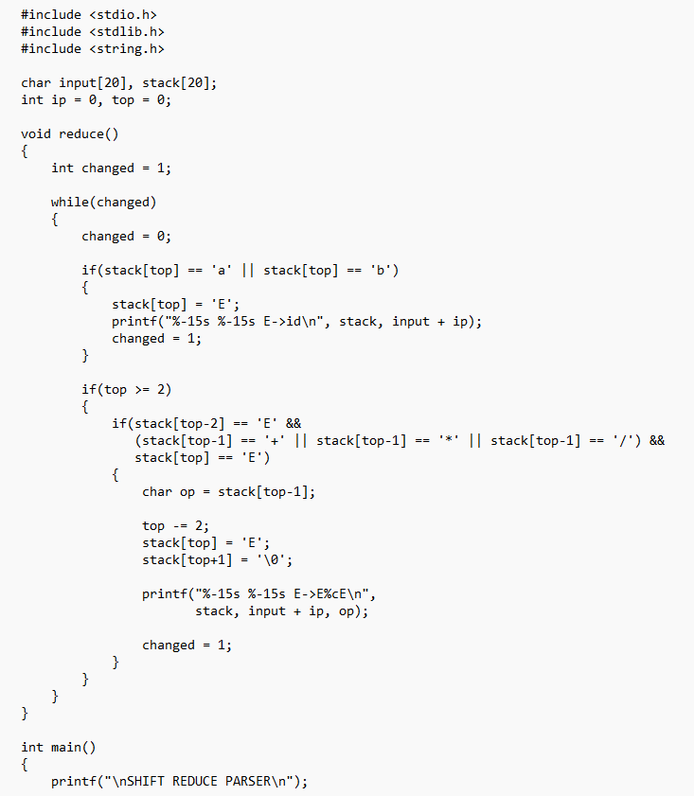
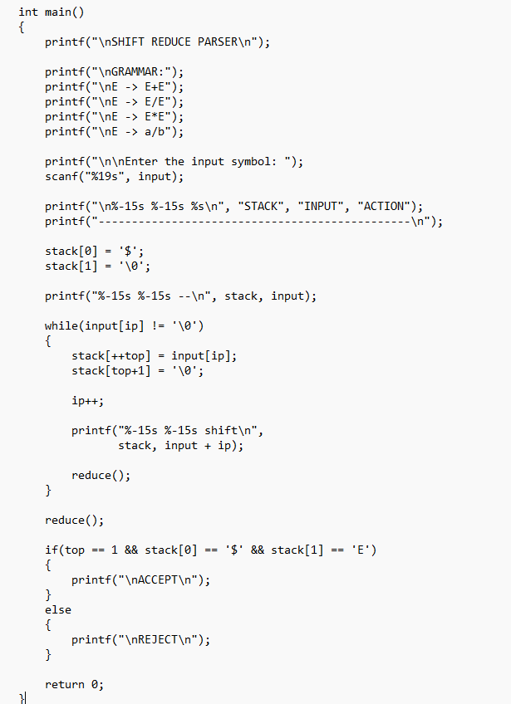

OUTPUT:-
